SHRI RAJASTHANI SEVA SANGH’S SMT.PARMESHWARIDEVI DURGADUTT TIBERWALA LIONS JUHU COLLEGE OF ARTS, COMMERCE & SCIENCE
(Affiliated to University of Mumbai) (Autonomous)
JB Nagar, Andheri East Mumbai, Maharashtra - 400059


ON JOB TRAINING (OJT)

TITLE: ON THE JOB TRAINING EXPERIENCE REPORT

CLASS: M.Sc.I.T. – Part I (2025-26) SEMESTER: II

SUBMITTED BY (Name): Amaan Jabbar Sayyed

SEAT NUMBER: MIT251008

Under the esteemed guidance of Asst. Prof. Kirti Yadav

SUBMITTED TO
DEPARTMENT OF INFORMATION TECHNOLOGY

Ms. Kirti Yadav | Mr. Mukesh Sharma | Dr. Sandeep Poddar
Subject In-charge | Coordinator | I/C Principal

For Partial Fulfillment for Degree of
Master of Science (Information Technology) in 2025-26

ACKNOWLEDGEMENT

I would like to express my sincere gratitude to my institute for providing me with the opportunity to undertake On Job Training (OJT) as a part of the M.Sc. IT Part-I Semester II curriculum. This opportunity has played a significant role in enhancing my practical knowledge and providing real-world industry exposure.

I am highly thankful to Robonic Infotech for giving me the opportunity to work as a Software Developer, where I gained valuable hands-on experience in a professional environment. During my training, I worked on real-time applications such as school ERP systems (IRIS School System), RoboCRM, and the development of a centralized RoboChurch system. This experience helped me understand real-world application development using technologies like ASP.NET WebForms (.NET Framework 4.7), SQL Server, JavaScript, and front-end integrations.

I would also like to express my heartfelt appreciation to my mentors and team members at Robonic Infotech for their constant guidance, support, and encouragement throughout the training period. Their valuable suggestions and continuous feedback helped me improve my technical skills, debugging abilities, and understanding of live project workflows.

Furthermore, I extend my gratitude to my faculty coordinator and the institute for their continuous support and guidance during the successful completion of my OJT and this report.

Finally, I would like to thank everyone who directly or indirectly contributed to making this learning experience meaningful and enriching.

Sr.  No. | Title | Page No. | Signature
1 | Introduction (About Organization) | 1
2 | Objectives | 2
3 | Roles and Responsibilities | 3
4 | OJT Undertaking | 4
5 | Resume | 5
6 | Internship Offer Letter | 6
7 | Monthly Report – January 2026 | 7
8 | Monthly Report – February 2026 | 8
9 | Monthly Report – March 2026 | 9
10 | Attendance Sheet | 10
11 | Supervisor Evaluation of OJT Student | 11
12 | Performa for Evaluation of OJT by Institute | 12
13 | Completion Certificate | 13
14 | Student Feedback | 14

INTRODUCTION ABOUT ORGANIZATION
About Organization – Robonic Infotech
Robonic Infotech is a software development and IT solutions company that focuses on building efficient, scalable, and user-friendly applications for educational institutions and organizational management. The company primarily specializes in developing ERP (Enterprise Resource Planning) systems, CRM solutions, and customized web-based applications that streamline daily operations and improve overall productivity.

One of the key products of Robonic Infotech is EduSoft ERP, a comprehensive school management system designed to handle various academic and administrative activities such as student management, admissions, fee collection, attendance, examinations, timetable management, and reporting. The ERP system is widely used by schools to digitize and automate their processes, ensuring accuracy, efficiency, and better data management.

In addition to ERP solutions, Robonic Infotech also works on applications like IRIS School System, which are advanced school management platforms with dynamic dashboards, reporting systems, and real-time data visualization. The organization has also developed RoboCRM, which is used for managing staff, enquiries, HR operations, and internal workflows, helping organizations maintain structured and centralized data management.

The company emphasizes real-time project development and practical exposure, allowing developers to work on live systems used by actual clients. The primary technology stack includes ASP.NET WebForms (.NET Framework 4.7), SQL Server, JavaScript,AJAX and frontend technologies like HTML and CSS. Developers are involved in both frontend and backend development, database management, debugging, and system optimization.

During my association with Robonic Infotech, I gained hands-on experience working on live ERP and CRM systems. I contributed to modules such as dashboard development, dynamic calendar integration, report generation, database handling, bug fixing, and performance optimization. I also worked on enhancing existing systems and participated in the development of a centralized application called RoboChurch.

Through this training, I gained a clear understanding of how real-world enterprise applications are designed, developed, maintained, and optimized in a professional environment, along with improving my technical and problem-solving skills.
.

OBJECTIVES

The main objective of this On Job Training (OJT) was to gain practical exposure to real-world software development in enterprise-level applications. The training aimed to enhance my understanding of web-based application development using technologies such as ASP.NET WebForms (.NET Framework 4.7), SQL Server, and JavaScript, and to bridge the gap between theoretical knowledge and industry practices. It also helped me develop strong problem-solving skills and understand how real-world ERP and CRM systems are developed, maintained, and optimized in a professional environment.

• To gain hands-on experience in developing and maintaining web applications using ASP.NET WebForms and SQL Server.

• To understand real-world development workflows including frontend design, backend logic implementation, and database integration.

• To work on live projects such as school ERP systems (EduSoft ERP, IRIS School) and RoboCRM.

• To learn database operations including writing SQL queries, stored procedures, data handling, and optimization.

• To understand debugging, error handling, and performance improvement in live production systems.

• To enhance skills in creating dynamic dashboards, reports, and data-driven modules.

• To gain experience in implementing new features and modifying existing systems based on client requirements.

• To improve communication, teamwork, and professional work ethics in a real organizational environment.

ROLES & RESPONSIBILITIES

During my On Job Training at Robonic Infotech, I worked as a Software Developer and was actively involved in developing, maintaining, and enhancing real-time enterprise applications. My responsibilities included working on both frontend and backend development, understanding client requirements, and implementing features in existing ERP and CRM systems. This experience helped me gain practical knowledge of real-world application development and improved both my technical and professional skills.

I contributed to applications such as school ERP systems (EduSoft ERP, IRIS School), RoboCRM, and the development of a centralized RoboChurch system. My work involved user interface improvements, backend logic implementation, database management, debugging, and performance optimization in live production environments.

• Developed and enhanced web pages using ASP.NET WebForms (.NET Framework 4.7), HTML, CSS, and JavaScript to create responsive and user-friendly interfaces.

• Worked on backend logic and business processes using C# and integrated them with SQL Server databases.

• Performed database operations such as writing SQL queries, stored procedures, joins, and data handling for various modules.

• Worked on live ERP systems (IRIS School System) including dashboard development, dynamic calendar integration, and report generation.

• Contributed to RoboCRM by handling modules related to staff management, HR processes, enquiry handling, and access control.

• Implemented features such as QR code generation, file uploads (image, PDF, Word), and data export (Excel, PDF, ZIP).

• Identified and resolved real-time issues such as data mismatches, incorrect calculations, and system errors in production.

• Worked on improving system performance by optimizing queries and fixing logic errors.

• Assisted in developing new modules such as timetable upload pages and centralized system (RoboChurch).

• Collaborated with team members, followed coding standards, and implemented changes based on client requirements and feedback.

OJT UNDERTAKING

Student Name | Amaan Jabbar Sayyed
Current Address | Behind Mehru Manzil , Near Vaibhavi Villa, Church Road Marol Andheri East Mumbai 400059
Residence Address | Behind Mehru Manzil , Near Vaibhavi Villa, Church Road Marol Andheri East Mumbai 400059
Email ID | amaansayed63@gmail.com
Mobile No | 8433829855
Aadhar Card | 9127 8428 8270
PAN Card
Overall GPA
Mode of Internship | Work From Office
I confirm that I agree with the terms, conditions, and requirements of the OJT Policy.

Student Signature Date :
I confirm that the student has attended the OJT orientation, and he has met all paperwork and process requirements to participate in the OJT programme and has received approval from his mentor.

Coordinator

Date :

RESUME

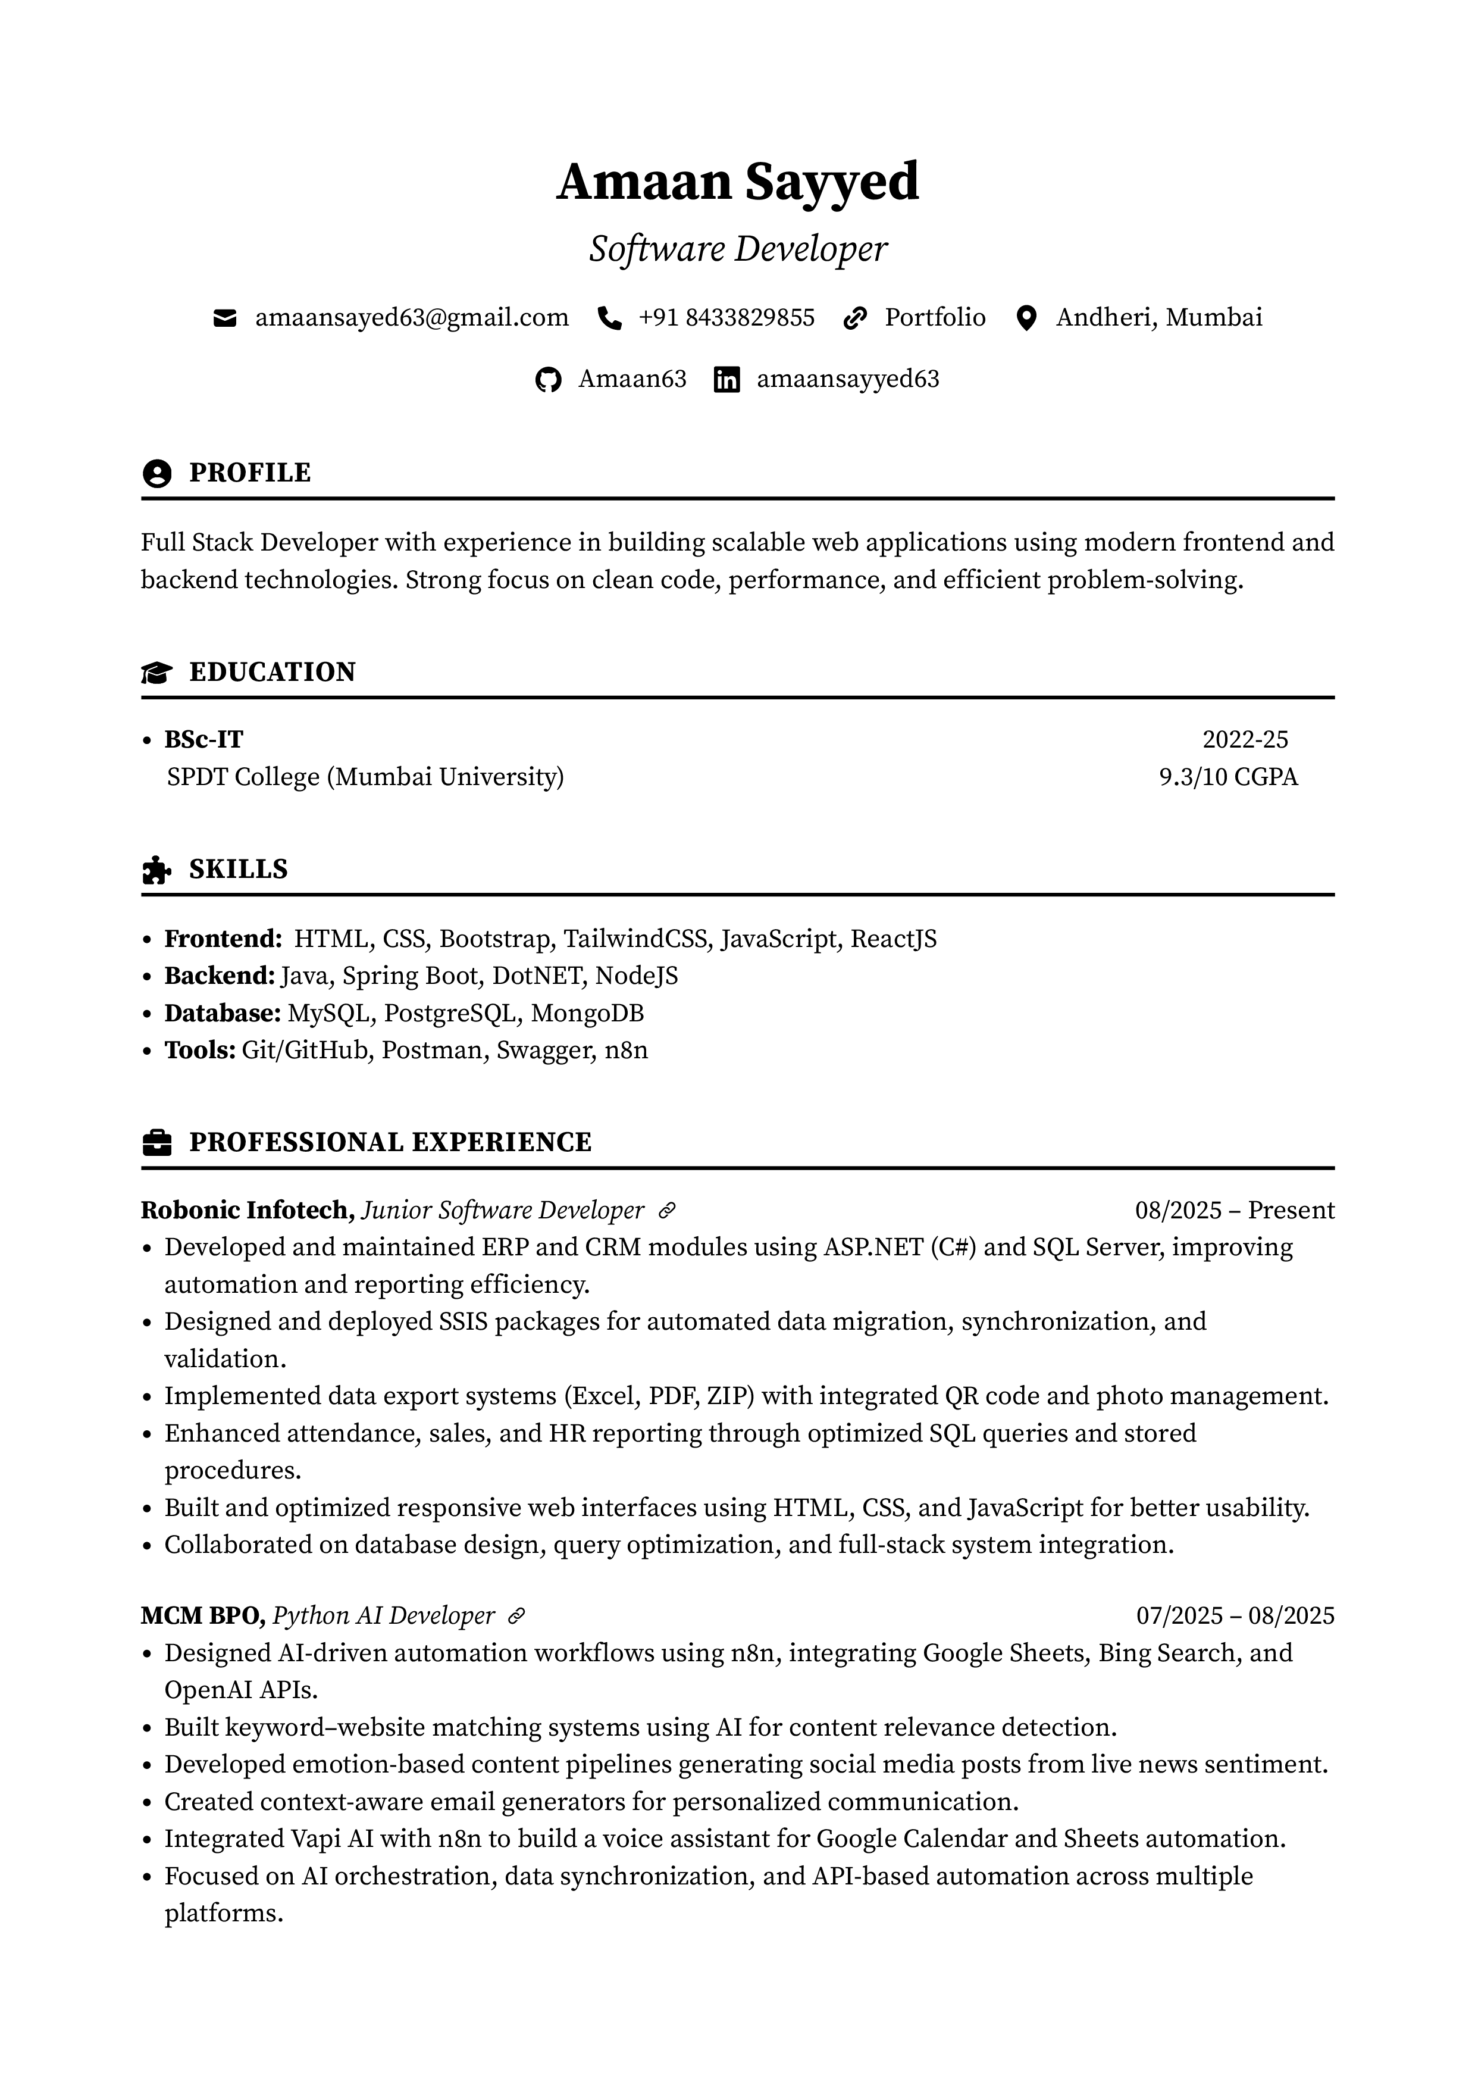

INTERNSHIP OFFER LETTER

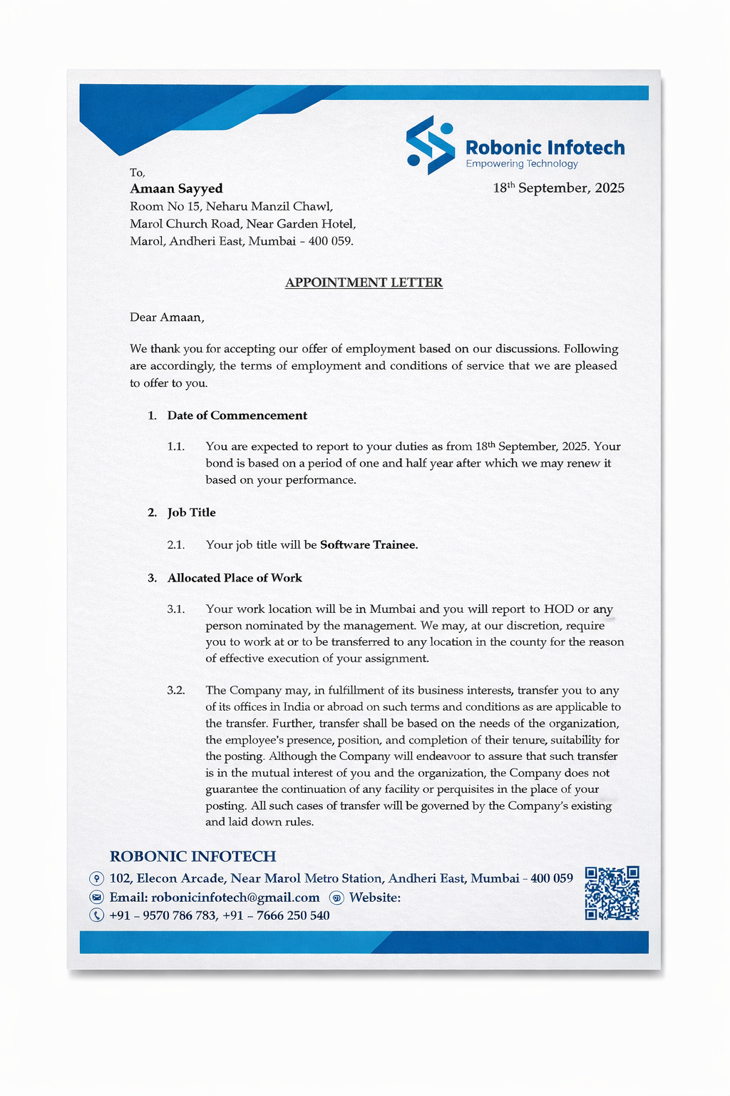
MONTHLY REPORT – JANUARY 2026

PROGRESS REPORT FOR THE MONTH OF JANUARY 2026
Organization Name | Date of Report | Student Signature
Robonic Infotech | 30/01/2026
Name of Student | Amaan Jabbar Sayyed
Reporting Person Name and Designation | Sanket, Team Leader
Reporting Person’s Contact Details | -
Job Description and Responsibilities | During this month, I worked as a Software Developer and was mainly involved in maintaining and enhancing the RoboCRM system along with handling minor changes and fixes in demo school ERP projects. My work focused on understanding existing systems, debugging issues, and implementing required modifications based on client and internal requirements.  I performed tasks such as fixing frontend and backend issues, working with SQL queries for data correction, and improving existing functionalities. I also handled small feature updates and ensured proper working of modules in live and demo environments. This month helped me build a strong foundation in understanding real-world application structure and debugging techniques.
Technology Used during Internship | ASP.NET WebForms (.NET Framework 4.7)  C#  SQL Server  JavaScript  AJAX  Visual Studio
Overall Learning Experiences | Learning Experience | During this month, I gained practical exposure to working on existing enterprise applications. I improved my understanding of how real-world systems are structured and learned how to debug and fix issues in live projects.
 | Skills Learnt | - Debugging and Issue Resolution  - SQL Query Writing and Data Handling  - Understanding Existing Codebase
 | Knowledge Acquired | - Understanding of ERP architecture  - Client-server interaction and API flow
Personal SWOC Analysis during Internship | Strength | - Quick learner  - Strong analytical thinking  - Good problem-solving skills
 | Weakness | - Sometimes overthink solutions  - Limited initial understanding of large existing  - Limited initial understanding of large existing systems  - Tendency to focus too much on perfection
 | Opportunities | Gained hands-on experience working on live CRM systems and real client requirements
 | Challenges | Understanding existing codebase and debugging issues in a live production environment

MONTHLY REPORT – FEBRUARY 2026

PROGRESS REPORT FOR THE MONTH OF FEBRUARY 2026
Organization Name | Date of Report | Student Signature
Robonic Infotech | 26/02/2026
Name of Student | Amaan Jabbar Sayyed
Reporting Person Name and  Designation | Sanket, Team Leader
Reporting Person’s Contact  Details | -
Job Description and Responsibilities | During this month, I worked on live school ERP systems such as IRIS School System along with RoboCRM. I was involved in developing new features, enhancing existing modules, and fixing real-time issues in production systems.  My responsibilities included working on dashboard-related functionalities, handling data representation, and modifying system behavior based on client requirements. I also worked on database queries, improved data accuracy, and ensured proper functioning of different modules. Additionally, I contributed to backend logic updates and frontend improvements to enhance overall user experience.  This month marked my transition from basic issue handling to working on more complex modules in ERP systems, including data processing, reporting logic, and system enhancements.
Technology Used during Internship | ASP.NET WebForms (.NET Framework 4.7)  C#  SQL Server  JavaScript  AJAX  Visual Studio
Overall Learning Experiences | Learning Experience | During this month, I gained deeper exposure to live ERP systems and understood how large-scale applications handle real-time data, reporting, and user interactions. I improved my ability to implement changes in running systems without affecting existing functionality.
 | Skills Learnt | - Working with Live ERP Systems (IRIS School) CRUD Operations  - Advanced SQL Query Handling and Data Processing
 | Knowledge Acquired | - API integration in applications  - Knowledge of handling client-based requirements and system updates
Personal SWOC Analysis during Internship | Strength | - Ability to adapt to new modules and requirements Ability to work independently and in a team  - Better understanding of real-time systems
 | Weakness | - Managing complex logic in large modules.  - Time required to understand interconnected systems
 | Opportunities | Opportunity to work on live ERP systems and handle real client requirements
 | Challenges | Handling complex data logic and ensuring accuracy in reports and dashboards

MONTHLY REPORT – MARCH 2026

PROGRESS REPORT FOR THE MONTH OF MARCH 2026
Organization Name | Date of Report | Student Signature
Robonic Infotech | 31/03/2026
Name of Student | Amaan Jabbar Sayyed
Reporting Person Name and Designation | Sanket, Team Leader
Reporting Person’s Contact Details | -
Job Description and Responsibilities | During this month, I worked on advanced development tasks in IRIS ERP systems and contributed to the centralized RoboChurch system. I handled admission and examination modules, implemented backend logic, and ensured proper data flow between systems. I also resolved data inconsistencies, improved report accuracy, and assisted in system integration. This phase involved working independently on complex requirements and enhancing overall system functionality.
Technology Used during Internship | ASP.NET WebForms (.NET Framework 4.7)  C#  SQL Server  JavaScript  AJAX  Visual Studio
Overall Learning Experiences | Learning Experience | During this month, I gained in-depth experience in handling complex modules and system integrations. I developed a better understanding of how large ERP systems manage multiple interconnected functionalities and how to implement scalable solutions.
 | Skills Learnt | - Payment Gateway Integration  - Handling Complex ERP Modules (Admission & Examination)  - Debugging & Optimization
 | Knowledge Acquired | - Understanding of admission and examination workflows in ERP systems  - Experience in integrating multiple modules within a single system  - Knowledge of centralized system architecture (RoboChurch)
Personal SWOC Analysis during Internship | Strength | - Strong problem-solving and debugging skills Strong analytical thinking  - Better understanding of system architecture Adaptable to new technologies
 | Weakness | - Handling highly complex logic requires more time  - Need for further improvement in optimization techniques
 | Opportunities | Opportunity to work on advanced ERP modules and centralized system development
 | Challenges | Managing integration between multiple modules and ensuring data consistency across the system

ATTENDANCE SHEET

Name & Address of Organization
Robonic Infotech,
Mumbai , Maharashtra

Name of the Student | Amaan Jabbar Sayyed
Seat Number | MIT251008
Name of Course | MSC IT Part I
Date of Commencement  of Training | September 2025
Date of Completion of Training | April 2026

 | Week | Monday | Tuesday | Wednesday | Thursday | Friday | Saturday
 | 1 | - | 27-01-2026 | 28-01-2026 | 29-01-2026 | 30-01-2026 | -
 |  |  | (Sign) | (Sign) | (Sign) | (Sign)
 | 2 | 02-02-2026 | 03-02-2026 | 04-02-2026 | 05-02-2026 | 06-02-2026 | -
 |  | (Sign) | (Sign) | (Sign) | (Sign) | (Sign)
 | 3 | 09-02-2026 | 10-02-2026 | 11-02-2026 | 12-02-2026 | 13-02-2026 | -
 |  | (Sign) | (Sign) | (Sign) | (Sign) | (Sign)
 | 4 | 23-02-2026 | 24-02-2026 | 25-02-2026 | 26-02-2026 | 27-02-2026 | -
 |  | (Sign) | (Sign) | (Sign) | (Sign) | (Sign)
 | 5 | 02-03-2026 | 03-03-2026 | - | 05-03-2026 | 06-03-2026 | -
 |  | (Sign) | (Sign) |  | (Sign) | (Sign)
 |   6 | 09-03-2026 | 10-03-2026 | 11-03-2026 | 12-03-2026 | 13-03-2026 | -
 |  | (Sign) | (Sign) | (Sign) | (Sign) | (Sign)
 | 7 | 16-03-2026 | 17-03-2026 | - | - | - | -

Total Days Present
Total Days Absent
Total Days
ATTENDANCE

Name & Signature of OJT Supervisor (with date)

10

SUPERVISOR EVALUATION OF OJT STUDENT

Student Name: Date: OJT Supervisor: Title: Organization:
OJT Address: Dates of OJT: From To

Please evaluate the intern based on the points mentioned in the table below.

S.no. | Particular | Marks
1 | Complete of Hours (out of 20)
2 | Quality/Performance (out of 20)
3 | Punctuality/Regularity (out of 10)
Total (out of 50)

Overall performance of student intern (circle one): (Needs improvement/Satisfactory/Good/Excellent)

Additional comments, if any:

Signature of Industry/organization supervisor

11

PERFORMA FOR EVALUATION OF OJT BY INSTITUTE

- Name of Student
- Mob. No.
- Roll No.
- Branch/Semester
- Period of Training
- Address of Training Site/organization:
- Type of Work Date of Evaluation
Please rate the following:

S.no. | Particular | Marks
1 | Weekly Reporting (out of 15)
2 | Written Report (out of 20)
3 | Viva-Voce/Presentation (out of 15)
Total (out of 50)

Additional Remarks (if any):

Signature of Faculty Mentor

COMPLETION CERTIFICATE

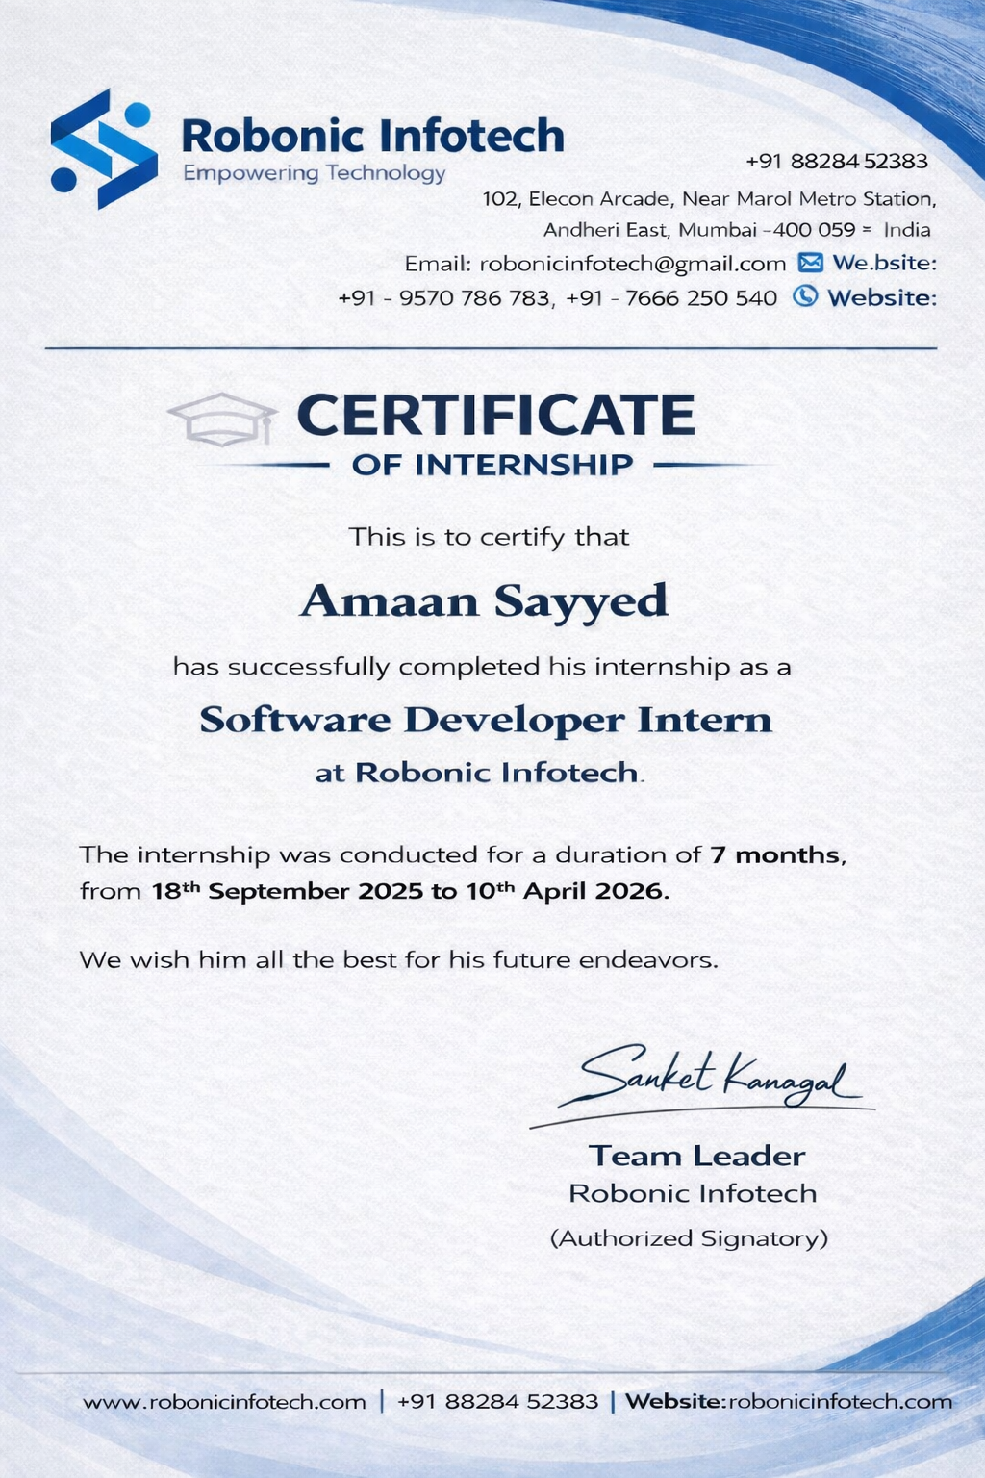

STUDENT FEEDBACK OF OJT

Student Name : Amaan Jabbar Sayyed Date : Organization Supervisor : Sanket Kanagal Title : Team Leader Supervisor Email : sanket@robonicinfotech.com OJT is : ☐ Unpaid ☐ Paid Organization : Robonic Infotech.
Organization Address : Mumbai, Maharashtra
Department : Information Technology

Dates of OJT : From : 27/01/2026 To : 17/03/2026

Give a brief description of your OJT work (title and tasks for which you were responsible) :
Was your internship experience related to your major area of study ?
- ☐ Yes, to a large degree.
- ☐ Yes, to a slight degree.
- ☐ No, not related at all.

Indicate the degree to which you agree or disagree with the following statements.

This experience has | Strongly Agree | Agree | Neutral | Disagree | Strongly Disagree
Given me the opportunity to explore a career field
Allowed me to apply classroom theory to practice
Helped me develop my decision making and problem-solving skills.
Expanded my knowledge about the work world before permanent employment.
Helped me develop my written and oral communication skills
Provided a chance to use leadership skills (influence others, develop ideas with others, simulate decision making and action)

This experience has | Strongly Agree | Agree | Neutral | Disagree | Strongly Disagree
Expanded my sensitivity to the
ethical implications of the work involved
Made it possible for me to be
more confident in new situations
Expanded my sensitivity to the ethical implications of the work
involved
Made it possible for me to be
more confident in new situations
Given me a chance to improve
my interpersonal skills
Helped me learn to handle
responsibility and use my time wisely
Helped me discover new aspects
of myself that I didn’t know
existed before
Helped me develop new interest
and abilities
Helped me clarify my career
goals
Provided me with contacts which may lead to future employment
Allowed me to acquire information and/or use equipment not available at my
Institute

In the Institute OJT program, faculty members are expected to be mentors for students. Do you feel that your faculty coordinator served such a function? Why or why not?
The faculty coordinator provided necessary guidance during the OJT program by monitoring progress and offering general instructions. While most of the learning was self-driven, the support provided was helpful in completing the training successfully. More frequent interaction and detailed feedback could have further enhanced the overall learning experience.

How well were you able to accomplish the initial goals, tasks and new skills that were set down in your learning contract? In what ways were you able to take a new direction or expand beyond your contract? Why were some goals not accomplished adequately?
I was able to accomplish most of the initial goals and tasks outlined in my learning contract. I successfully applied my knowledge of full-stack development by working on real-world applications such as CRM and E- commerce systems. I also gained hands-on experience in API development, database integration, payment gateway implementation, and deployment using platforms like Vercel and Render, which helped me expand beyond the initial scope of learning.

In what areas did you most develop and improve?
During my OJT, I showed significant improvement in full-stack development and problem-solving skills. I enhanced my knowledge of React, Node.js, and MongoDB, and gained practical experience in building scalable web applications. I also improved my debugging skills, time management, and ability to handle real-world project requirements.

What has been the most significant accomplishment or satisfying moment of your OJT? The most significant accomplishment during my OJT was successfully developing and deploying full- stack applications. Integrating the Razorpay payment gateway and deploying projects on platforms like Vercel and Render was a very satisfying experience, as it allowed me to build real-world, production- ready applications.

What did you dislike about the OJT?
One aspect I found challenging during the OJT was the limited level of continuous mentorship, which sometimes required extensive self-learning. However, this also helped me become more independent and improved my problem-solving abilities.

Considering your overall experience, how would you rate this OJT? (Circle one).
Satisfactory / Good / Excellent

Give suggestions as to how your OJT experience could have been improved. (Could you have handled added responsibility? Would you have liked more discussions with your professor concerning your OJT? Was closer supervision needed? Was more of an orientation required?)
The OJT experience could have been improved with more regular mentorship sessions and detailed feedback. A structured orientation at the beginning and more collaborative discussions would have enhanced the learning process. I also feel I could have taken on additional responsibilities to gain deeper practical exposure.

(Student Signature)
Name: Amaan Jabbar Sayyed
Seat No: MIT251008

Date :

